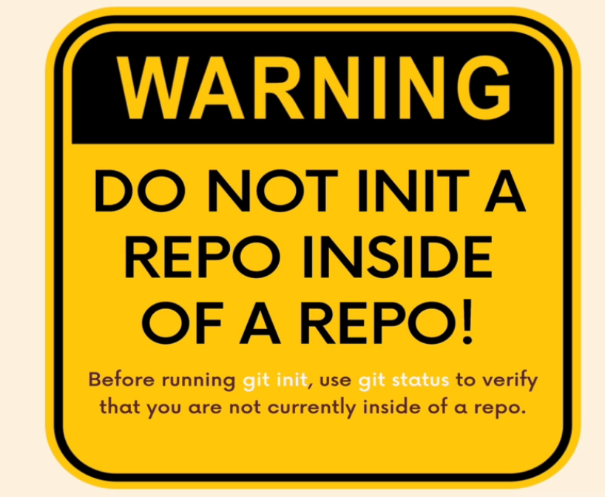

**Committing Basics Exercise**

1. Create a new folder called Shopping
2. Initialize a new git repo inside of the Shopping folder (make sure you're not already inside of a Git repo!)

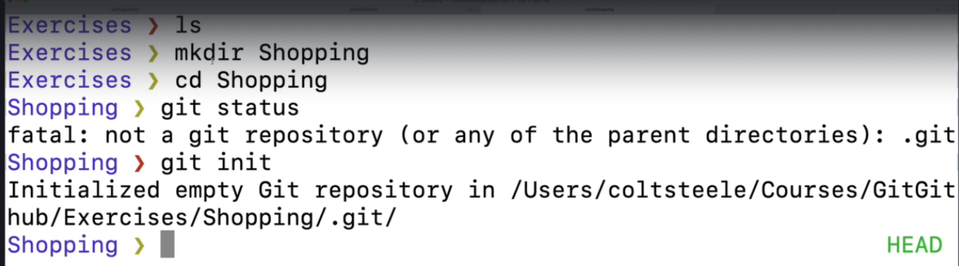

1. Make a new file called yard.txt



1. Make another new file called groceries.txt



1. Make a commit that includes both empty files. The message should be "create yard and groceries lists"

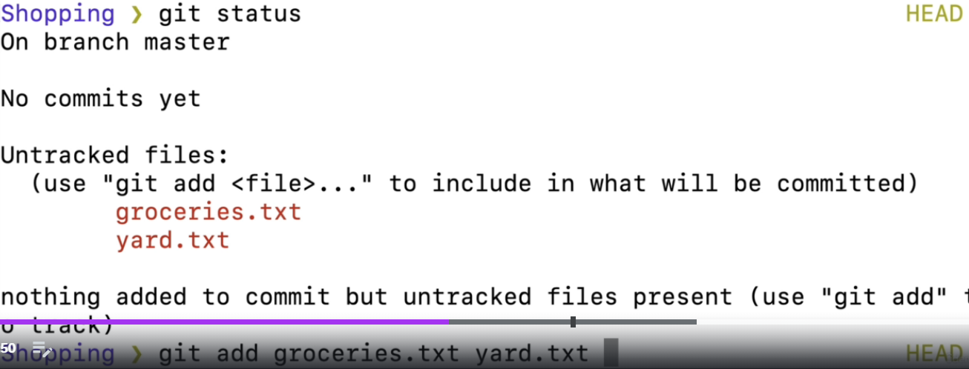

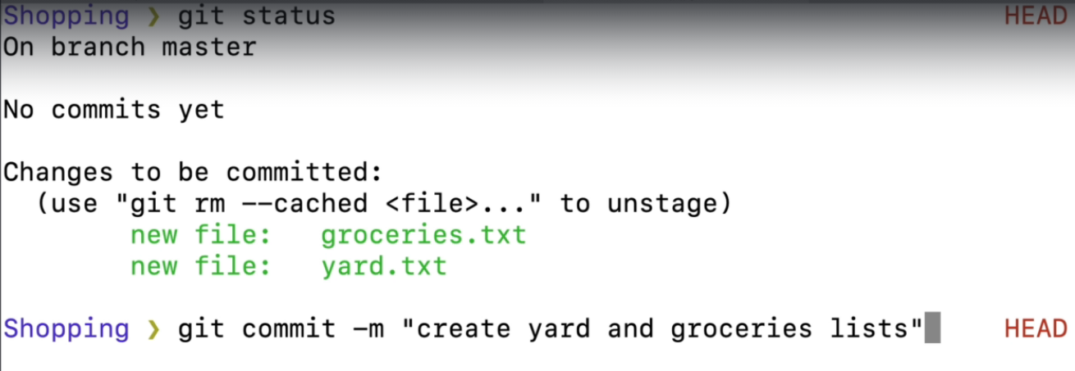

1. In the yard.txt file, add the following changes:
2. - 2 bags of potting soil
3. - 1 bag of worm castings
4. In the groceries.txt file, add the following:
5. - 4 tomatoes
6. - 6 shallots
7. - 1 fennel bulb
8. Make a new commit, including **ONLY the changes from the groceries.txt file.** The commit message should be "add ingredients for tomato soup"

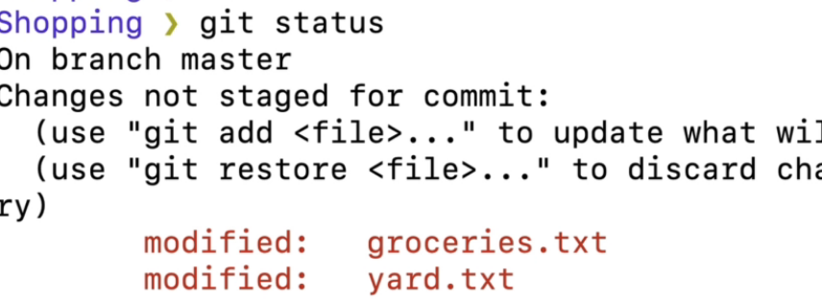

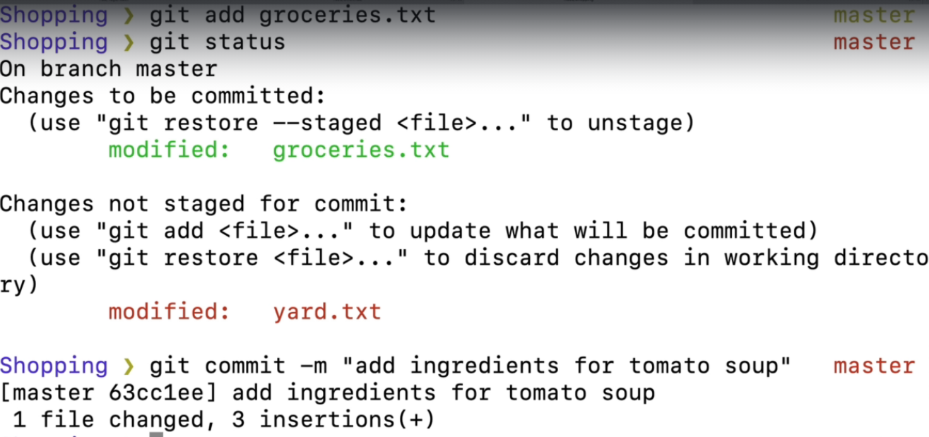

1. Make a second commit including **ONLY the changes to the yard.txt file.** It should have the commit message "add items needed for garden box"

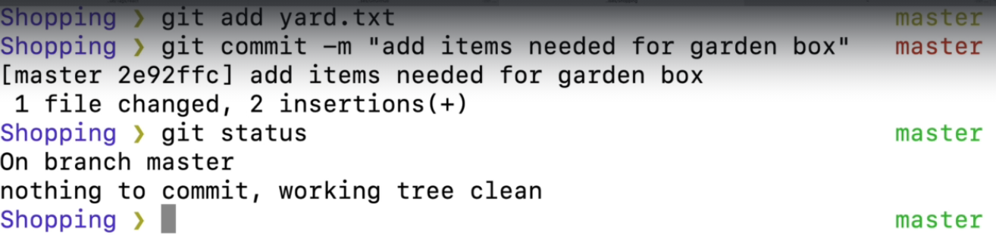

1. Next up, add the following line to the end of groceries.txt
2. - couple of seed potatos
3. In the yard.txt file, change the first line so that it says "**3** bags of potting soil" instead of "2 bags of potting soil"
4. - 3 bags of potting soil
5. - 1 bag of worm castings
6. **Make a commit that includes the changes to BOTH files.** The message should read "add items needed to grow potatoes"

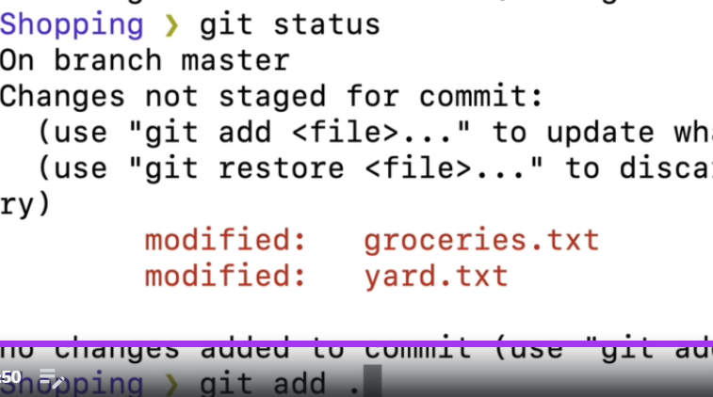

1. **Use a Git command to display a list of the commits. You should see 4!**



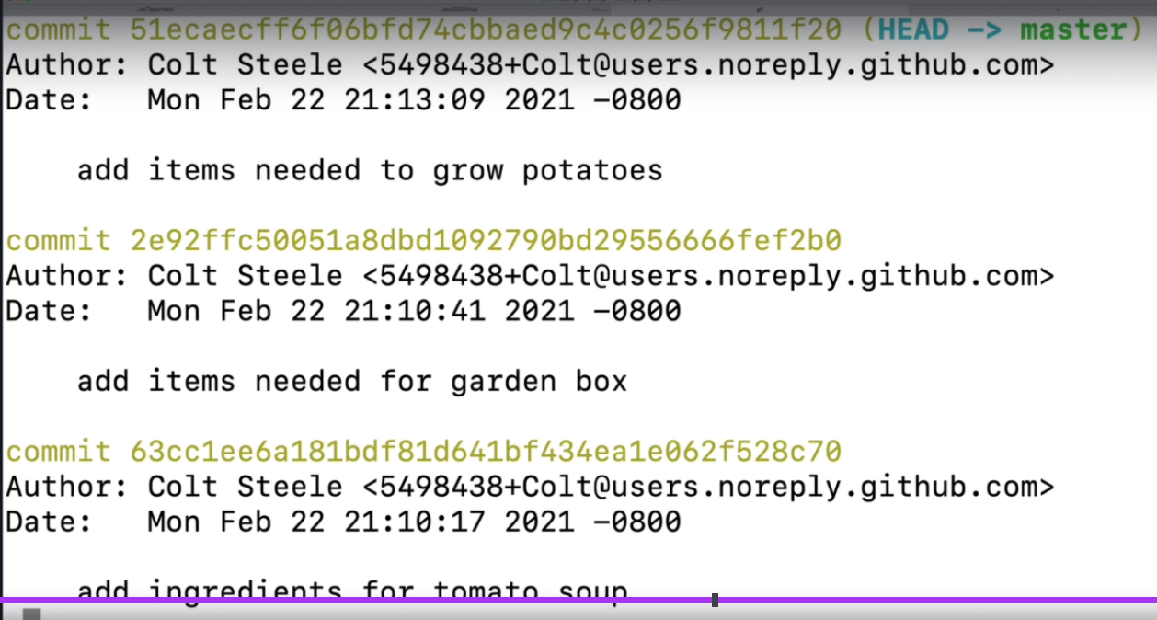

Atomic commit –

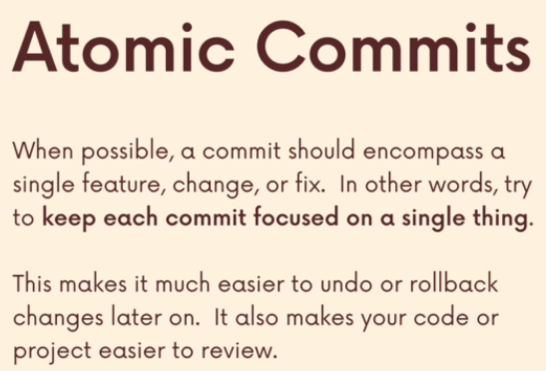

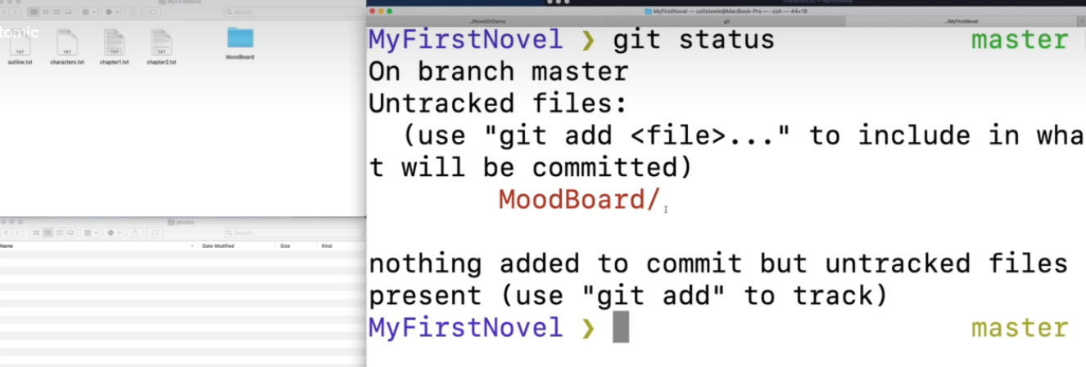

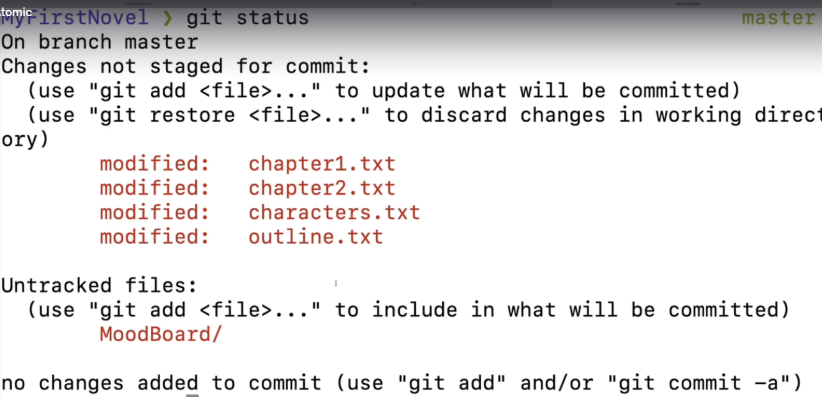

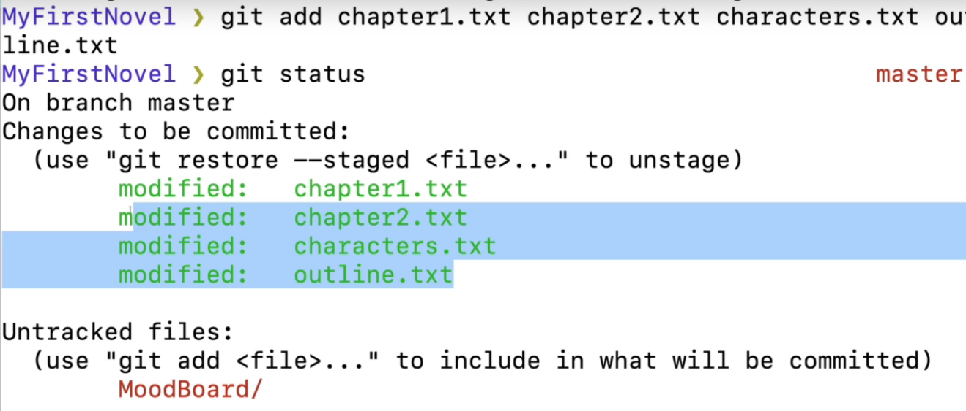

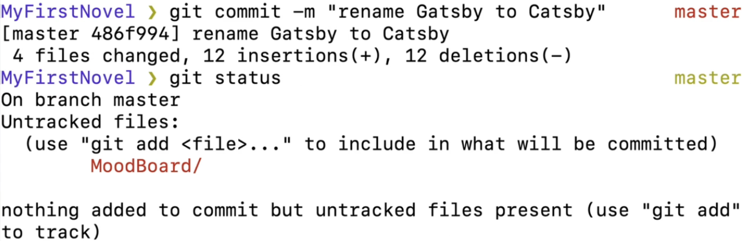

Now add the images folder MooodBoard

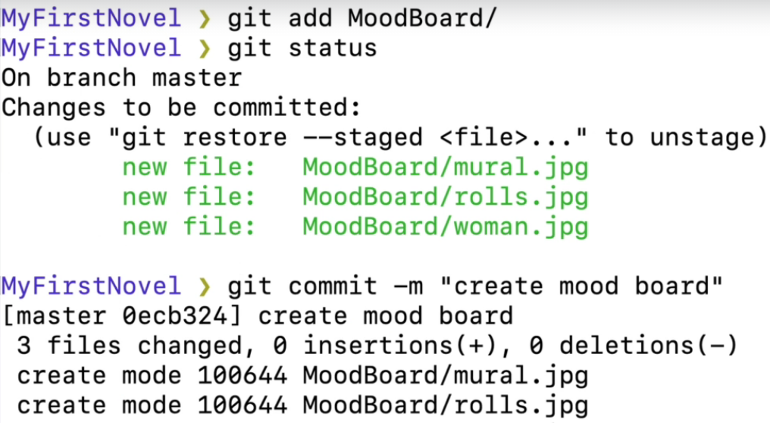

git log –oneline – displays list of all commits with 1 line description



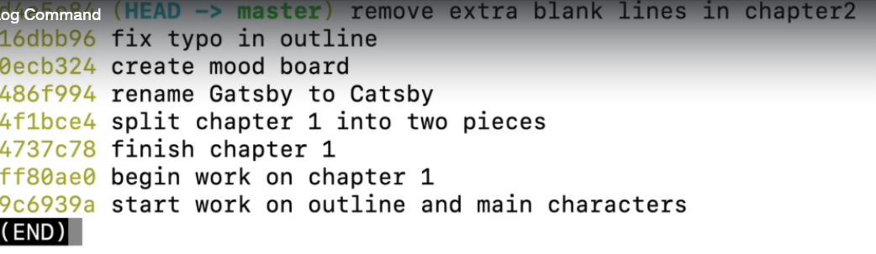

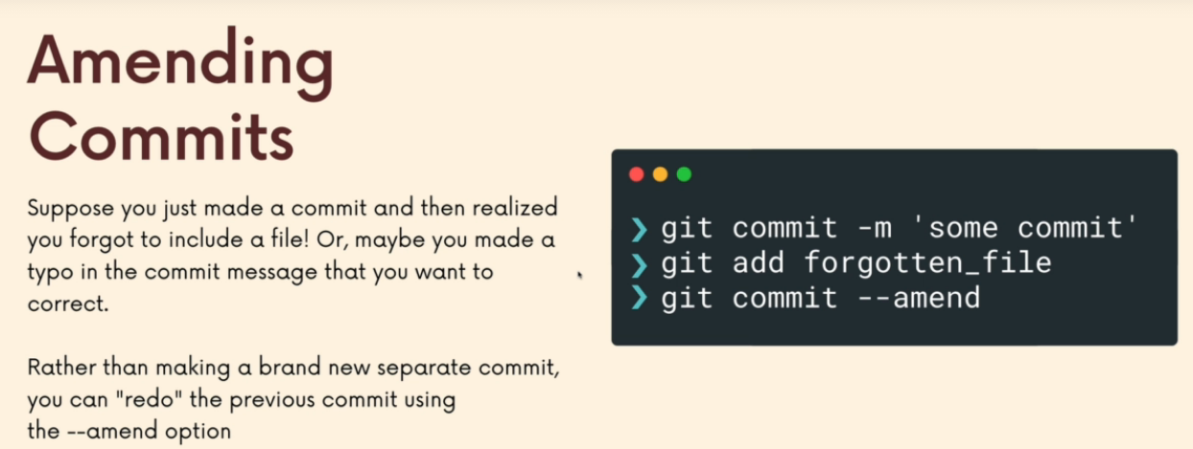

Suppose I forgot to commit 1 file. Here its outline.txt

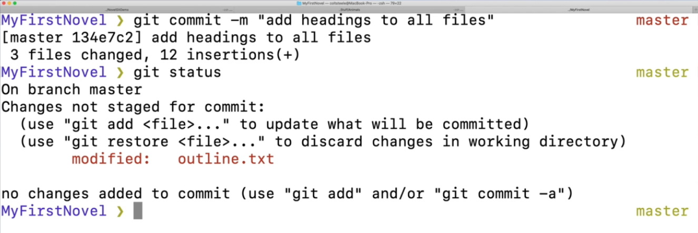

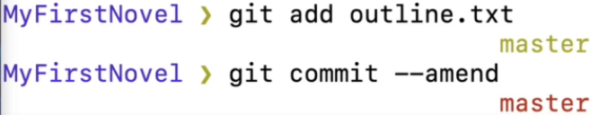

Opens the default editor(vim). In this case its set to vscode.

‘add headings to files’ is the commit msg used for previous commit. Can be changed if we want

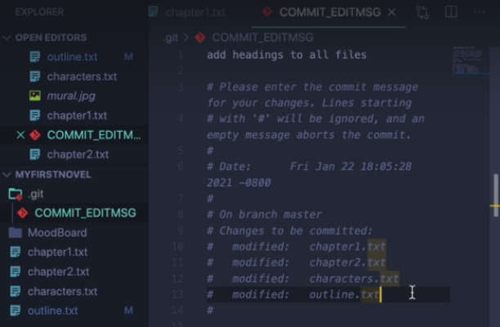

Git ignore

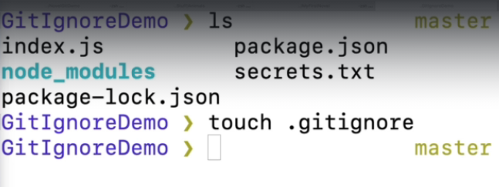

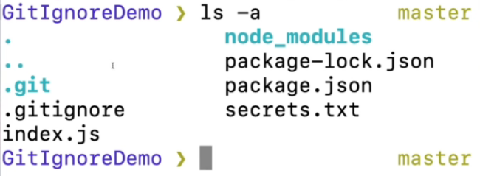

We want to ignore .DS_Store files, a file named secrets.txt, and node_modules directory

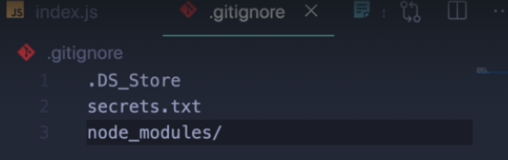

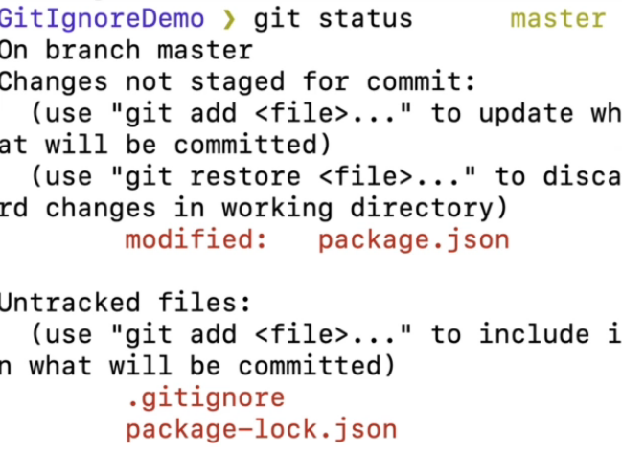

Commit the gitignore file as well

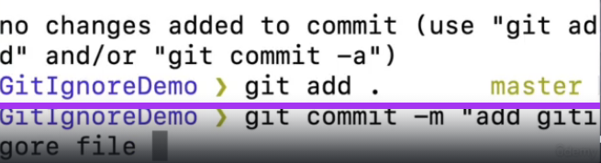

Branching –

Create new branch named oldies



To see list of existing branches –



Doing git log, we see head pointing to master

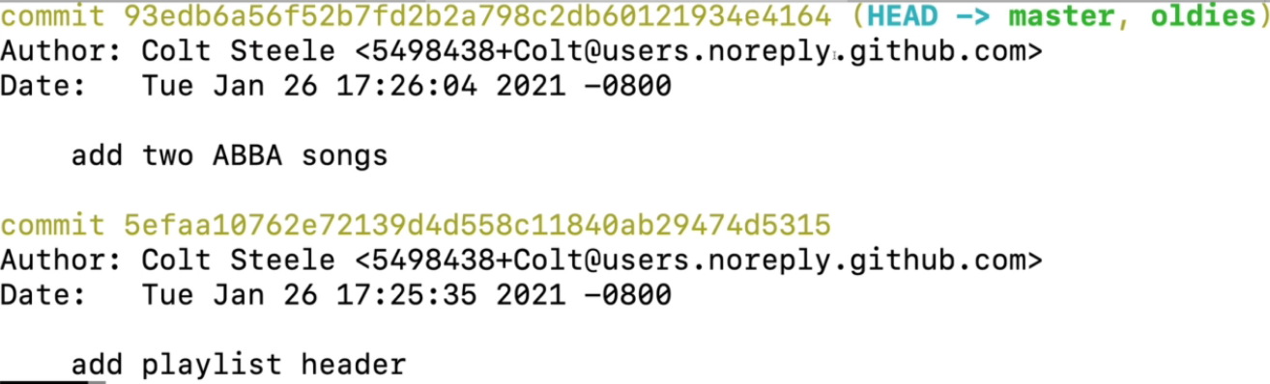

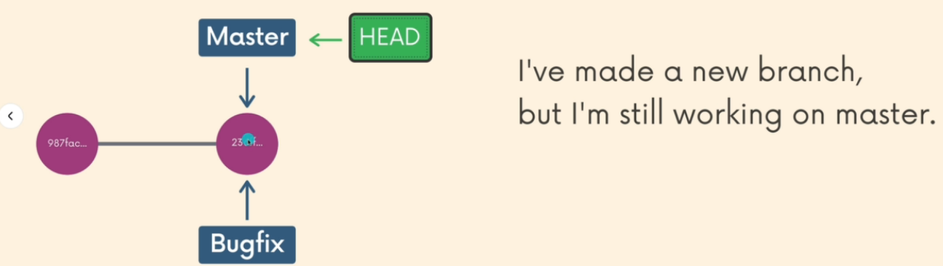

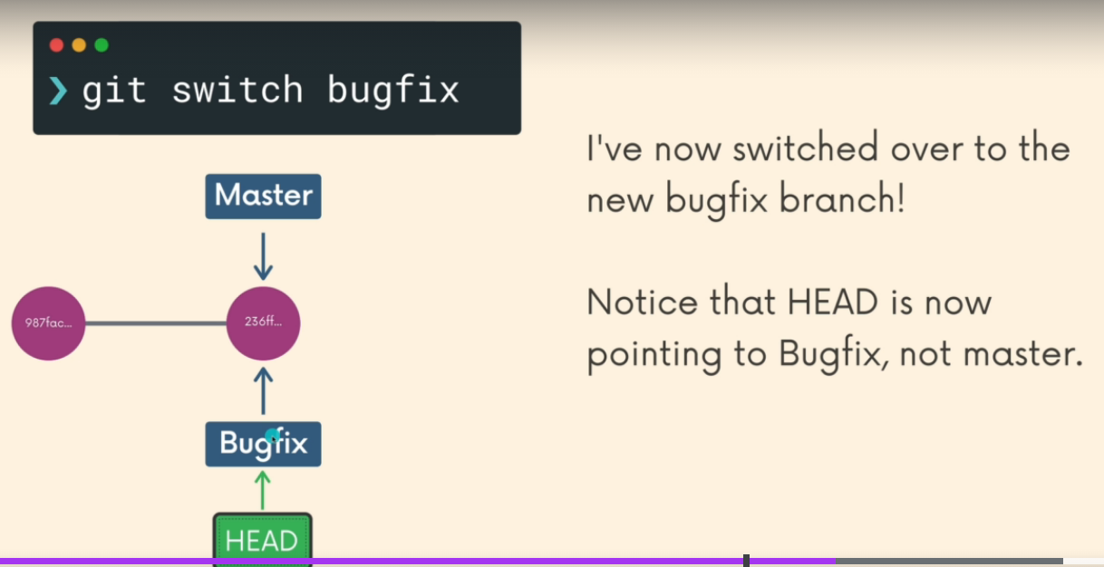

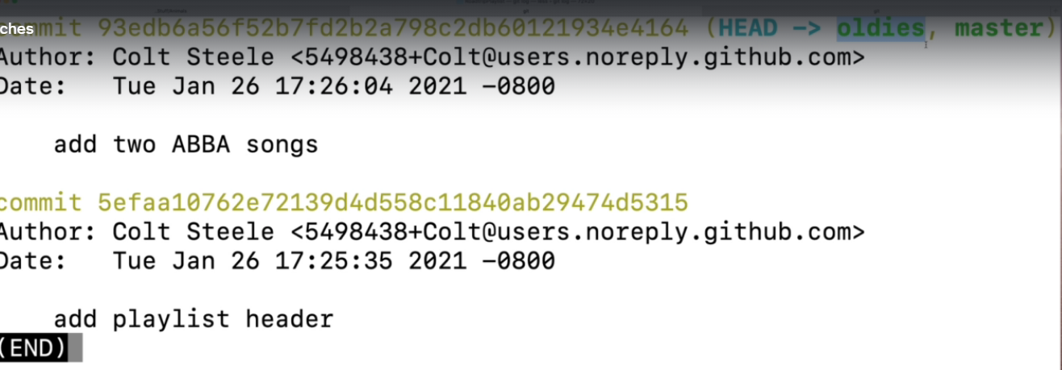

Now we commit some changes to playlist.txt in oldies branch

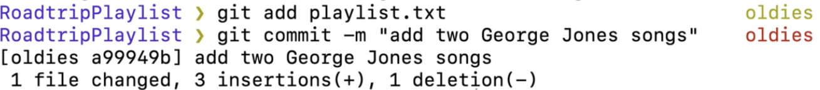

Git log –

Head pointing to oldies, master left behind

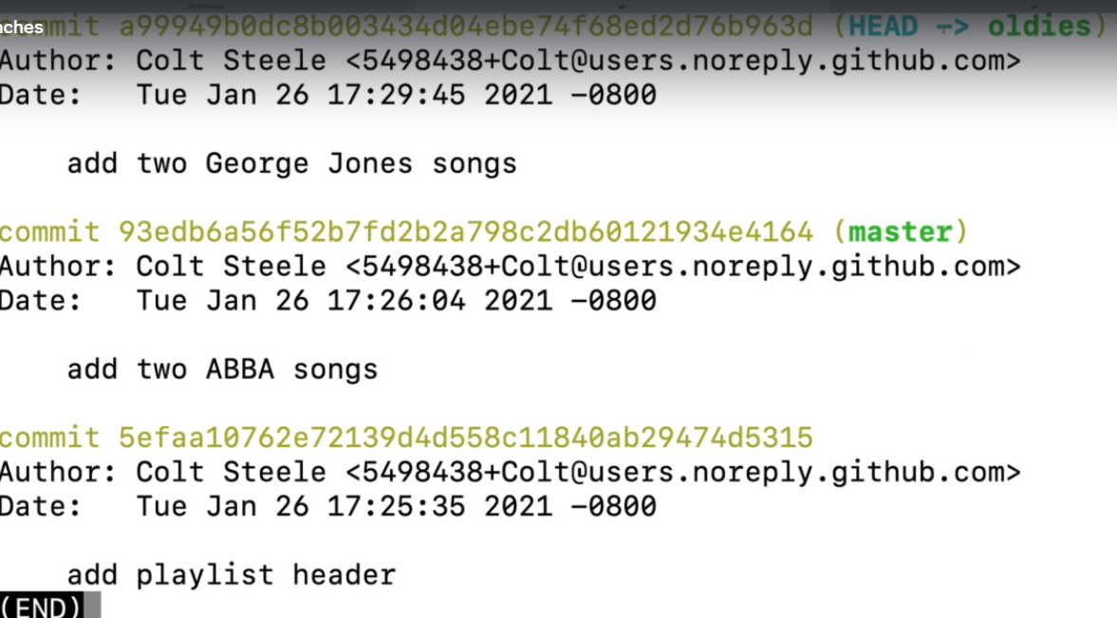

Creating a georges branch from oldies



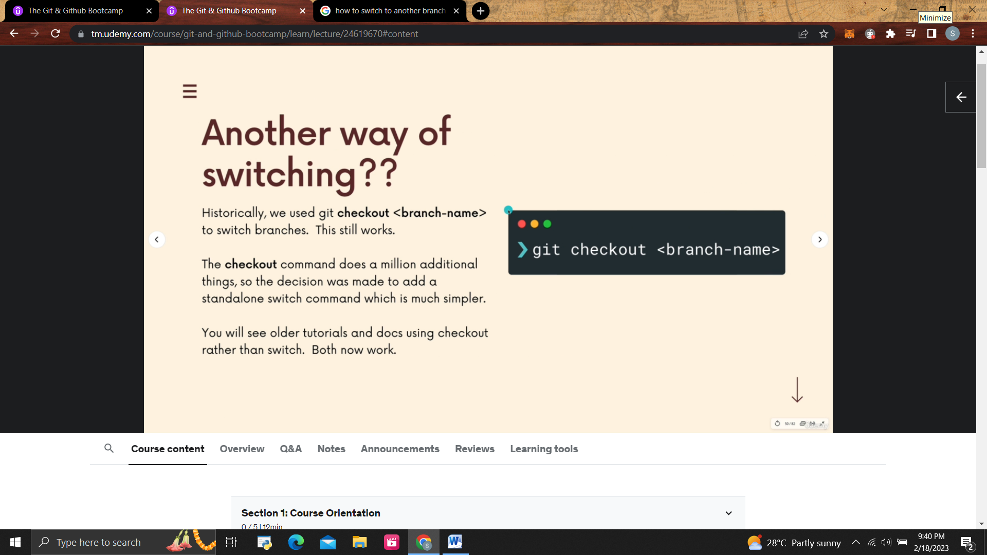

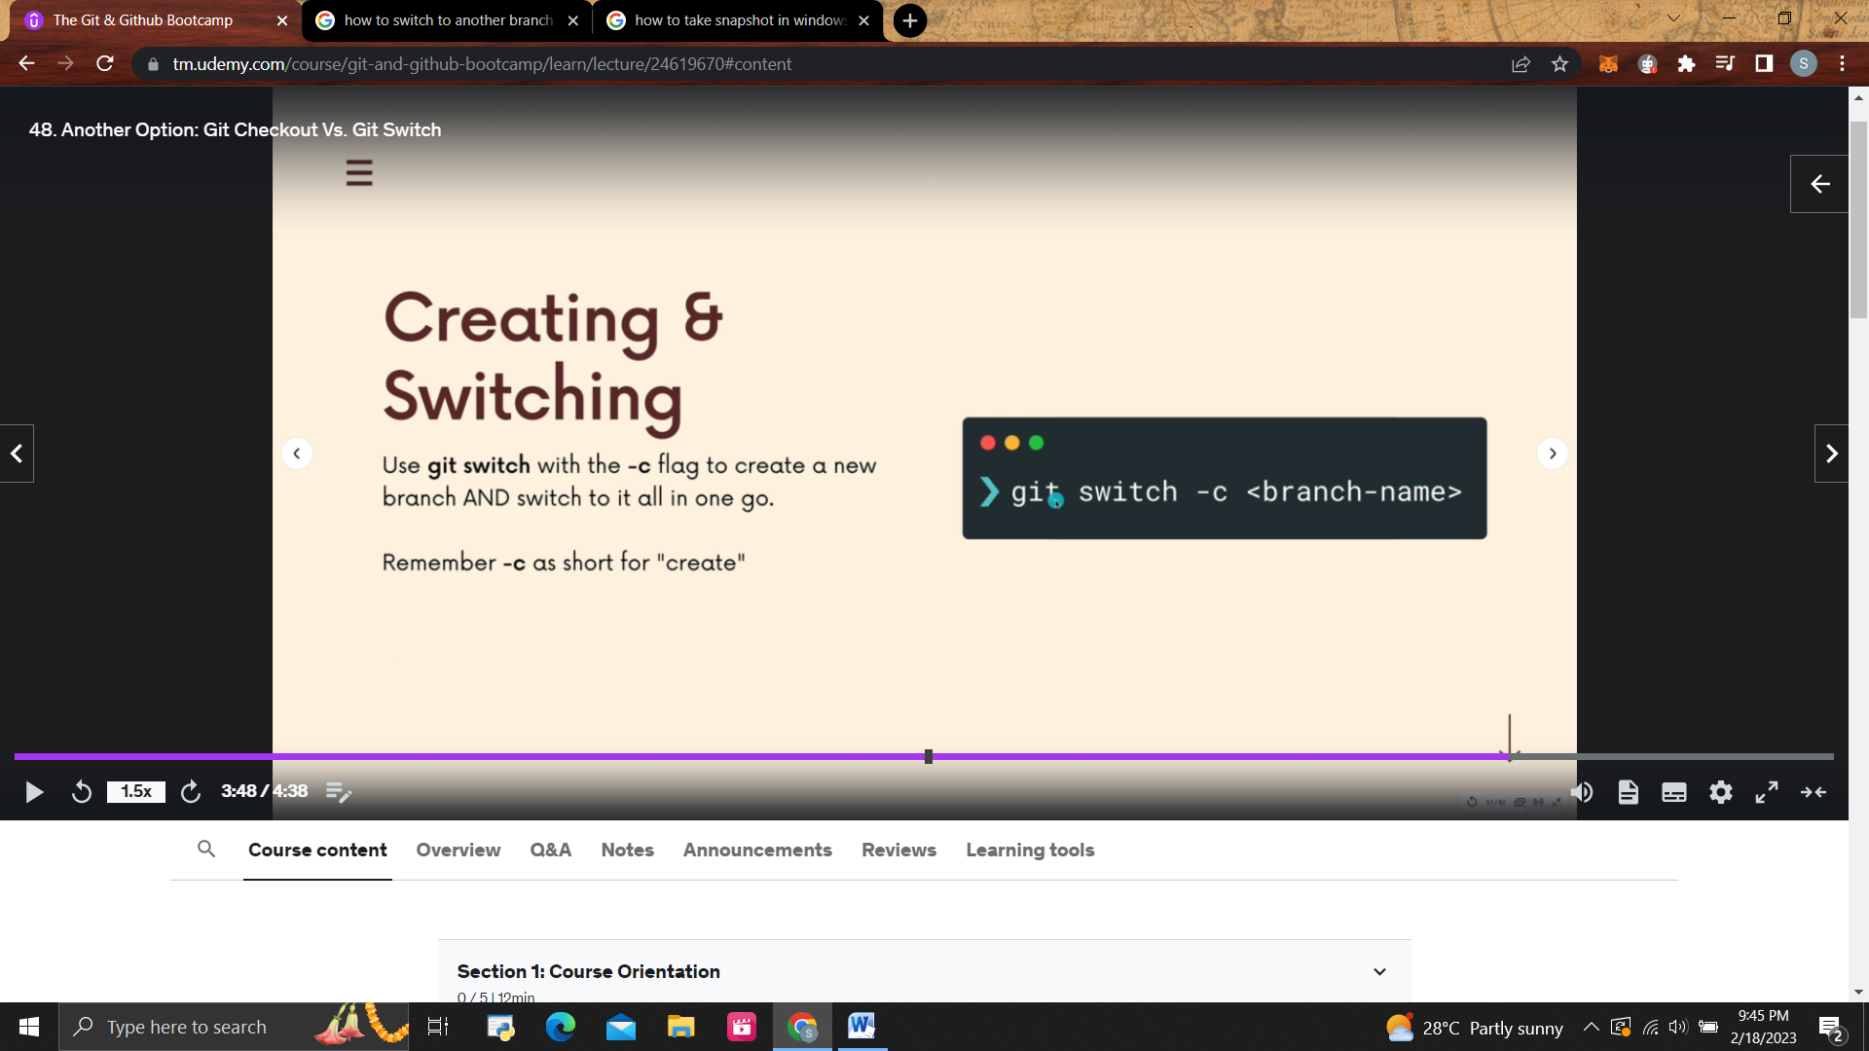

To rename a branch, move to the branch, and then rename it

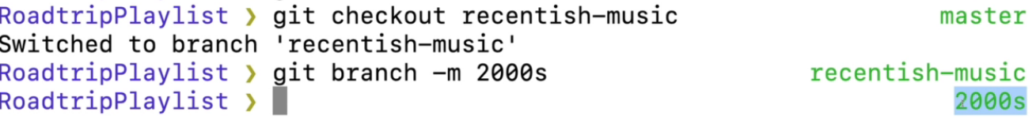

Branching Exercise

Make a new folder called Patronus

Make a new git repo inside the folder (make sure you're not in an existing repo)

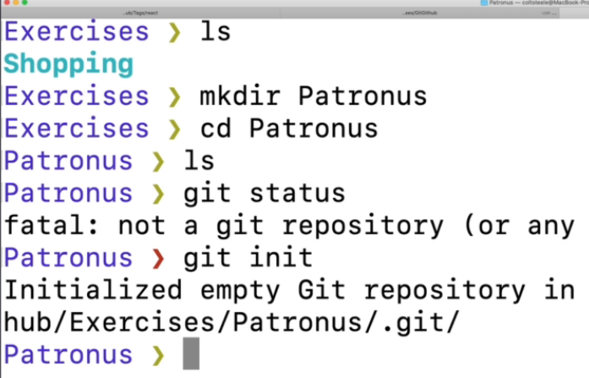

Create a new file called patronus.txt (leave it empty for now)

Add and commit the empty file, with the message "add empty patronus file"

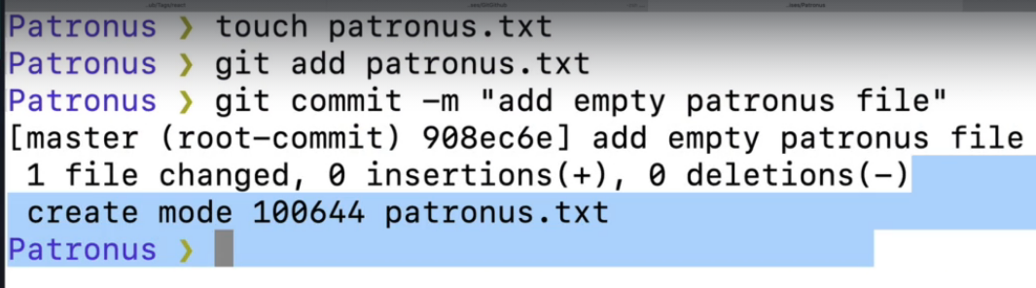

Immediately make a new branch called harry and another branch called snape (both based on the master branch)

Move to the harry branch using the "new" command to change branches.

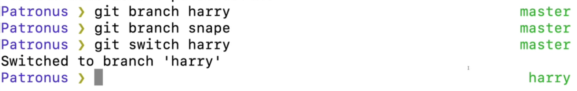

In the patronus.txt file, add the following:

Add and commit the changes, with the commit message "add harry's stag patronus"

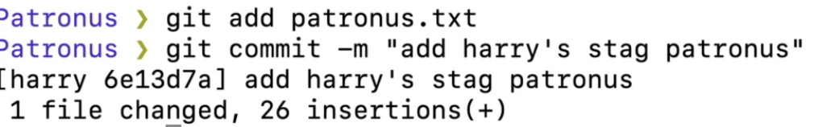

Move over to the snape branch using the "older" command to change branches.



Put the following text in the patronus.txt file:

Add and commit the changes on the snape branch with the commit message "add snape's doe patronus"

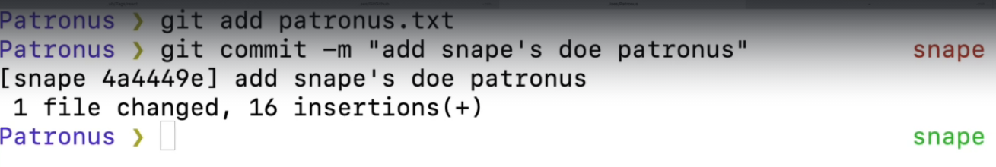

Next, create a new branch based upon the snape branch called lily

Move to the lily branch

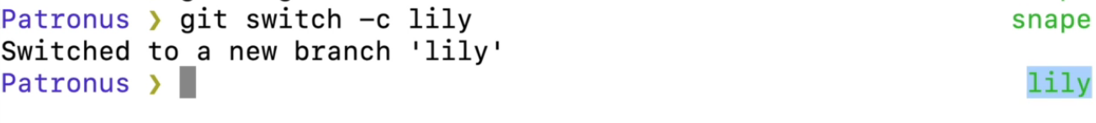

Edit the patronus.txt file so that it says LILY'S PATRONUS at the top instead of

SNAPE'S PATRONUS (leave the doe ascii-art alone)

Add and commit the change with the message "add lily's doe patronus"

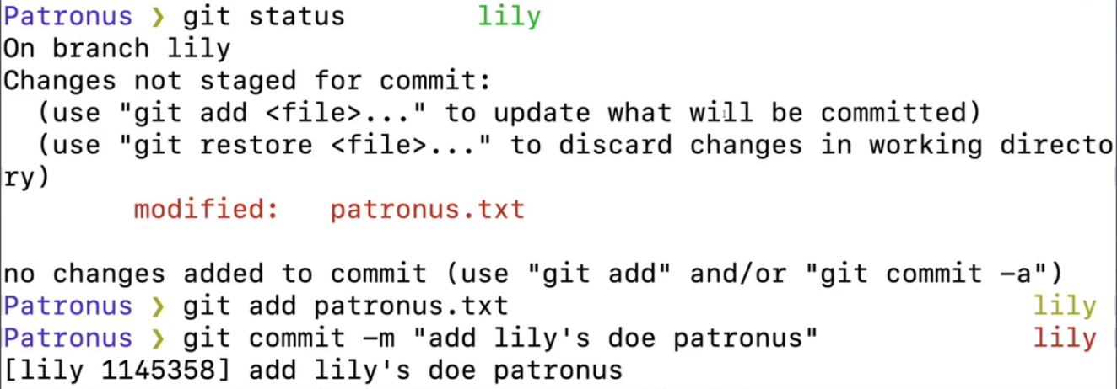

Run a git command to list all branches (you should see 4)



Bonus: delete the snape branch (poor Snape)



# Git Merging Exercise

This exercise is a little bit different. Rather than following my exact instructions step by step, I'd like for you to come up with your own scenarios that meet my requirements.

Start by creating a new repo. Make a file or two in the repo for you to work on.

If you need some inspiration...I'll be working in a file called greetings.txt It will contain greetings in different languages.

## Part 1: Fast Forward Merge

**Your goal is to generate a fast forward merge. Demonstrate that you understand how FF merges work by creating one on your own!**

Make a new branch. Do some work in the repo such that when you merge the new branch into master, it results in a fast forward merge. Merge that branch into master and see if you were right!

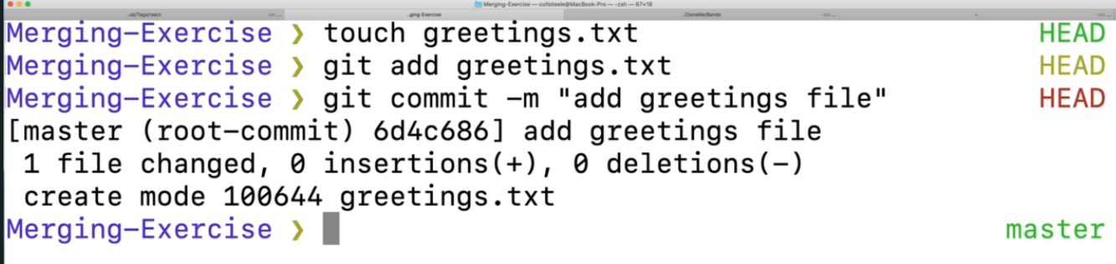



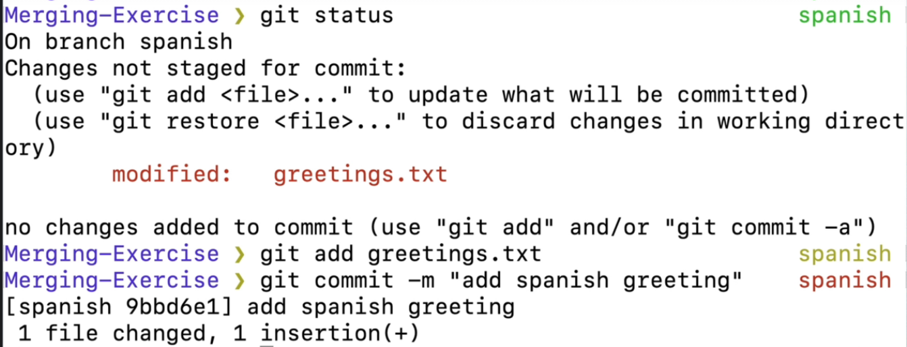

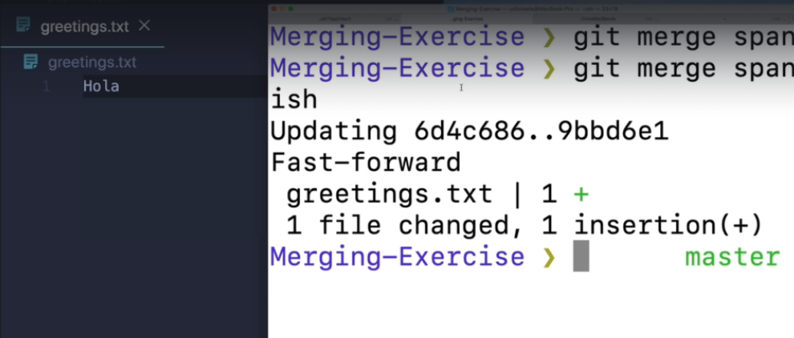

New branch French



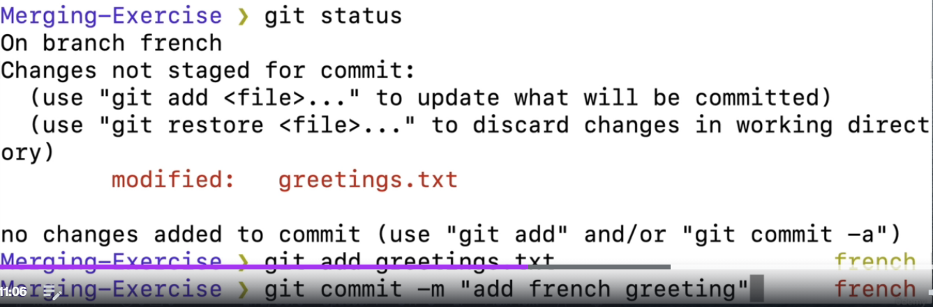

## Part 2: Merge Commit (No Conflicts)

Your goal is to generate a merge commit with NO MERGE CONFLICTS.

Create a new branch. Make some changes to the repo such that when you merge the new branch into master, it results in a merge commit. The merge should not result in any conflicts. Merge that branch into master and see if you were right!

## Part 3: Conflicts!

Your goal is to generate merge a conflict!

Create a new branch. Make some changes to the repo such that when you merge the new branch into the master branch, it results in a merge conflict. Merge that branch into master and see if you were right! Resolve the conflict!

**Undoing Things Exercise**

This exercise is based around the Beatles' song Yesterday, and the evolution of its lyrics over time.

* Clone the repo I've created for you, using the following command (make sure you're not already in a repo when you run it!)

git clone <https://github.com/Colt/yesterday-exercise>

* Change into the newly created directory. You should see a file called lyrics.txt

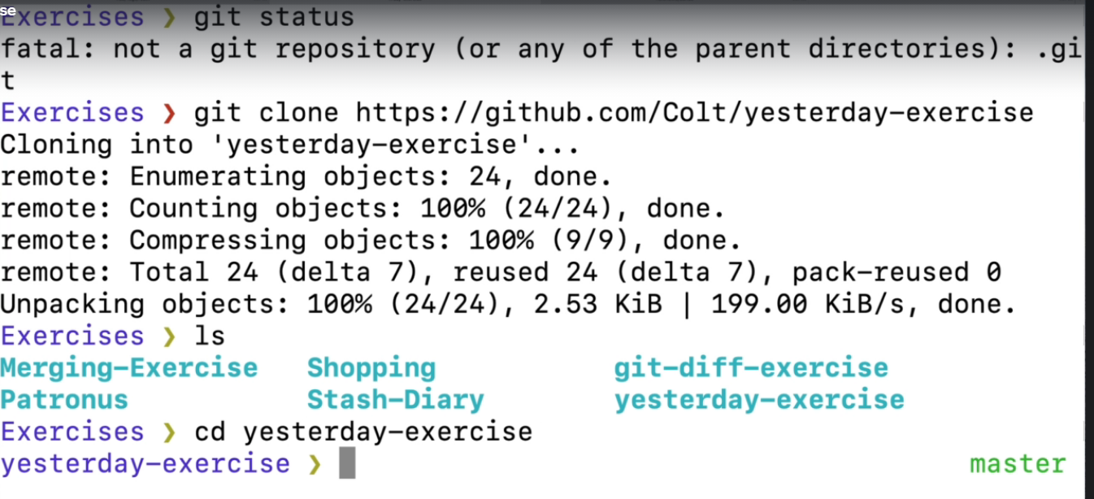

* Take a look at the commit history. You should see 8 commits on the master branch.

Gil log –oneline

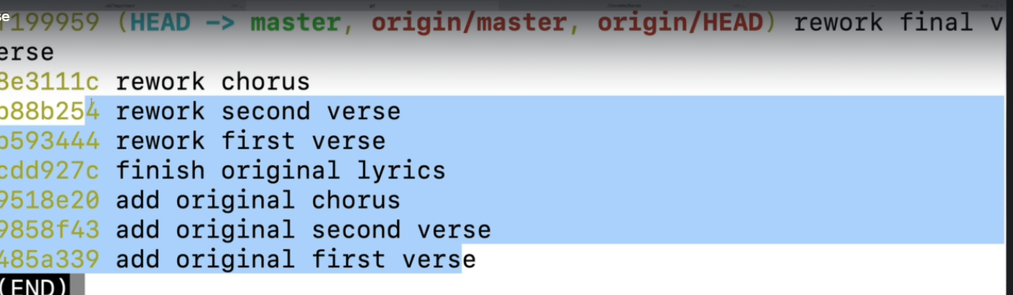

* Go "back in time" by checking out the very first commit. Remember, this puts you in detached HEAD. Take a look at the lyrics.txt file to verify things have changed. Then, leave detached HEAD by returning to the master branch.



* Go back to the commit where the original version of the lyrics was completed. The commit has the message "finish original lyrics". Create a new branch called scrambled-eggs based upon this commit.

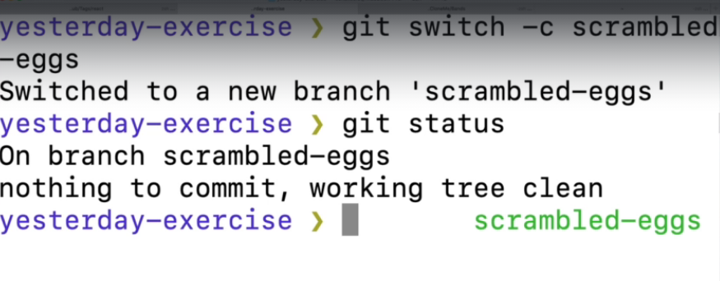

* Go back to the master branch
* Delete everything in the lyrics.txt file. Save the file.
* Oh no, that was a mistake! USING A GIT COMMAND, discard the changes you made to lyrics.txt since the last commit. We saw a couple of ways of achieving this.
* 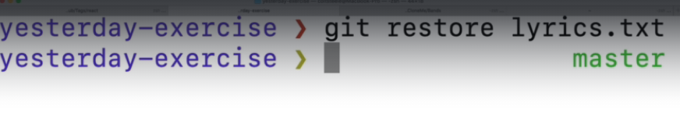



* Suddenly you get a creative itch! You want to write your own parody lyrics! Replace the contents of lyrics.txt with the following lyrics (from [this website](http://www.amiright.com/parody/60s/thebeatles1981.shtml))
* 404
* Guess this ain't the page you're looking for
* On this website there are thousands more
* With no error 404
* Suddenly
* This is not the page you thought you'd see
* But it's not an error 403
* Yes, 404s come easily
* Add and commit the changes on the master branch
* Add this to the bottom of the lyrics.txt file:
* Why it has to show, I don't know
* Or what it's for
* You typed something wrong?
* Here's no song - it's 404
* 404
* Adding 1% to twenty score
* (I put that line in 'cause it scans, no more)
* "Goodbye" from error 404
* Add and commit the changes to the master branch
* After more consideration, you realize that you actually don't want the previous two commits (the 404 parody lyrics) on the master branch. You want to move them to a new branch!
* Use a git command to "undo" the prior two commits on master. Make sure you **KEEP THE CHANGES IN YOUR WORKING DIRECTORY.** Just undo the two git commits. Your lyrics.txt file should still contain the 404 lyrics.
* Create a new branch called 404, switch to it, and add and commit the 404 lyrics in your working directory.
* Switch back to master and make sure lyrics.txt contains the actual lyrics to Yesterday